**PEARSON HND**

**IN COMPUTING (LEVEL 4)**

**AND DEVELOPMENT**

**WEBSIT DESIN**

**MOHAMMED MOHAMME ISLAM**

**DR. Mahmoud Saed Alkhouli**

**ALDAR ACADEMY**

GARHOUD

056 22 373 56, mohammedmohammedislam12@gmail.com



Table of Contents

**The World Wide Web: A Deep Dive into Connectivity** 3

**Understanding the World Wide Web** 3

**Naming the Web: Symbolism of (WWW)** 3

**Profound Benefits of the World Wide Web** 3

**Scrutinizing the World Wide Web: A Dual-Edged Sword** 4

**In-Depth Exploration: The Global Organization of Domain Names** 5

**Unraveling the Domain Name System (DNS)** 5

**Summing Up the Digital Landscape** 6

**Delving Deeper into the Inner Workings of Websites** 6

**Unveiling the Complexity: Anatomy of a Website** 7

**Crafting Excellence: The Importance of a Well-Structured Website** 7

**Navigating the Digital Highway: Communication Protocols** 7

**The Backbone: Server Hardware Essentials** 7

**Operating Systems: The Overlooked Pillars** 8

**Bridging the Gap: Web Server Software Insights** 8

**The Intricacies of Website Component Interaction** 9

**Understanding the Symbiotic Relationship** 9

**Seamless Integration Dynamics** 9

**Navigating the Terrain of Website Maintenance Challenges** 9

**Proactive Strategies for Operational Fluidity** 10

**Crafting a Holistic Report on Website Architecture** 10

**Unveiling the Core Components** 10

**Best Practices for Artful Report Creation** 10

**In-Depth Exploration: The Crucial Dimensions of Website Security and SEO Mastery** 11

**Unveiling the Essence of Website Security** 11

**Crafting a Comprehensive Digital Report** 12

**A Strategic Approach to Website Development** 13

**Unraveling the Profound Impact of Web Technologies and Frameworks on Website Dynamics** 13

**In-Depth Exploration of the Impact of Search Engines on Website Performance** 15

**Unraveling the Complexities of Search Engine Dynamics** 15

**Factors Influencing Website Performance:** 16

**Significance of Index Value:** 16

**Navigating Ranking Algorithms:** 16

**Strategic SEO Approaches:** 17

**Evidence-Based SEO Strategies:** 17

**Elevating Content Relevance:** 17

**User Experience and Site Speed Optimization:** 17

**Mobile-Friendly Design:** 18

**Technical SEO Best Practices:** 18

**Local SEO Strategies:** 18

**Continuous Monitoring and Adaptation:** 18

**Real-Life Case Studies:** 18

**Unraveling the Dynamics of Front-End and Back-End Website Technologies** 19

**Front-End Technologies:** 19

**Back-End Technologies:** 20

**Importance of Collaboration:** 21

**Emerging Trends:** 21

**Looking Towards the Future:** 21

**Distinguishing Online Web Development Tools and Custom-Built Websites** 22

**Design Flexibility:** 22

**Custom-Built Websites:** 22

**Performance:** 22

**Functionality:** 23

**User Experience (UX):** 23

**Online Web Development Tools:** 23

**Custom-Built Websites:** 23

**User Interface (UI):** 24

**Online Web Development Tools:** 24

**Custom-Built Websites:** 24

**In-Depth Guide: Developing, Hosting, and Managing a Custom-Built Website** 24

**1. Planning Your Custom-Built Website:** 24

**2. Development Process:** 25

**3. Hosting Solutions:** 25

**4. Website Management:** 26

**5. SEO Integration:** 26

**6. Challenges in Website Development and Management:** 27

**7. Benefits of a Custom-Built Website:** 27

**8. Ongoing Management:** 28

**Adaptation to User Feedback:** 28

**1. Methodology:** 28

**2. Evaluation Criteria:** 29

**3. Evaluation Results:** 29

**4. Formal Justification:** 30

**Restaurant Website Design Document** 31

**Project Overview:** 42

**Owner's Requirements:** 42

**Project Overview:** 44

**Design and Development Evaluation:** 44

**Test Plan for Restaurant Website** 46

**Assessing the Quality Assurance (QA) Process in Project Development** 50

**Objectives:** 50

**Assess Test Coverage:** 51

**Examine Defect Management:** 51

**Evaluate Automation Practices:** 51

**Analyze Collaboration:** 51

**Assessment Methodology:** 51

**Evaluation Criteria:** 52

**Recommendations and Improvement Plan:** 53

**Reporting and Presentation:** 53

**Conclusion:** 53

**The World Wide Web: A Deep Dive into Connectivity**

**Understanding the World Wide Web**

The World Wide Web (WWW) stands as a paradigm of interconnectedness, a vast communication network transcending global boundaries. This intricate web enables users to exchange diverse information, facilitated by the World Wide Web Protocol. The result is a global village, where individuals effortlessly connect, transcending distances within seconds.[1]

**Naming the Web: Symbolism of (WWW)**

The symbolic representation of the World Wide Web as (WWW) is not merely an acronym but a visual representation of a worldwide network. This nomenclature reflects the extensive interconnectivity of computer networks globally, whether through wired or wireless means. The choice of "World Wide Web" stems from its pervasive and intricate nature, resembling the delicate yet robust structure of spider webs. This intricate network comprises numerous pages interlinked to form websites, serving multifaceted purposes in education, tourism, health, trade, industry, social media, entertainment, and beyond.[1]

Key Players in the World Wide Web

**Customers:**

Users utilizing search engines and browsers to access desired information.

**Hosts:**

Individuals responsible for storing information on various internet pages, reaching customers through specialized programs.[1]

**Profound Benefits of the World Wide Web**

The Internet, integral to modern life, offers a multitude of advantages:

**Education and Knowledge:**

A vast repository of information and learning resources empowers individuals to find answers to diverse questions through search engines like Google and educational platforms like YouTube.[1]

**Electronic Marketing:**

The Internet serves as a crucial platform for electronic marketing, enabling efficient promotion of products and saving time and effort for customers.[1]

**Communication and Connectivity:**

Facilitates global communication through social networking sites, email, and various online methods, diminishing geographical barriers.[1]

**Scrutinizing the World Wide Web: A Dual-Edged Sword**

Despite its myriad advantages, the Internet has inherent drawbacks:

**Time Consumption:**

Abundance of entertainment options may lead to time wastage.

**Lethargy:**

Prolonged usage can induce lethargy and a sedentary lifestyle.

**Cultural Impact:**

Integration with diverse cultures may impact local customs and traditions.

**Reduced Social Interaction:**

Excessive screen time may contribute to reduced face-to-face social and family interactions.[1]

**In-Depth Exploration: The Global Organization of Domain Names**

In the interconnected world, the management of domain names plays a pivotal role. This involves overseeing unique identifiers assigned to entities on the internet, ensuring a robust and reliable system. The Internet Corporation for Assigned Names and Numbers (ICANN) takes center stage, overseeing the allocation of domain names and IP addresses globally. Additionally, regional and national authorities play a role in managing specific top-level domains (TLDs) within their jurisdictions.[2]

**Unraveling the Domain Name System (DNS)**

The Domain Name System (DNS) emerges as a critical component, serving as the backbone for human-readable addresses to access websites and online resources. This intricate system involves various types of DNS servers, each playing a specific role:[2]

**Recursive DNS:**

Resolves domain names by querying authoritative DNS servers on behalf of users.[2]

**Authoritative DNS:**

Holds official records for specific domain names, providing definitive information about associated IP addresses.[2]

**Caching DNS:**

Stores previously resolved domain name-to-IP address mappings, reducing latency for frequently accessed domain names.[2]

**Root DNS:**

Serves as the initial point of contact in the DNS hierarchy, storing information about authoritative DNS servers for top-level domains (TLDs).[2]

**TLD DNS:**

Manages specific TLDs, maintaining information about second-level domain names within their respective TLDs.

Understanding these intricacies is vital for grasping the complexity and efficiency of the domain name resolution process.[2]

**Summing Up the Digital Landscape**

The World Wide Web, with its profound impact on global connectivity, and the intricate domain name management, showcases the ever-evolving nature of the digital landscape. As we navigate this interconnected realm, the Internet continues to shape our experiences, fostering communication, knowledge exchange, and unprecedented possibilities.[2]

**Delving Deeper into the Inner Workings of Websites**

**Understanding the Nuances of Website Operations**

In the expansive digital landscape, websites serve as the bedrock of our online experiences. Gaining a profound understanding of their intricate inner workings is akin to unraveling a sophisticated technological code. Let's embark on a comprehensive exploration, delving into the fundamental components that shape a website—from communication protocols to server hardware, operating systems, and web server software. [3]

**Unveiling the Complexity: Anatomy of a Website**

A website is not merely a static collection of web pages; it is a dynamic entity orchestrated by various elements working in unison. From the foundational HTML and CSS to the integration of multimedia elements, each component plays a pivotal role in crafting a seamless and engaging user experience.[3]

**Crafting Excellence: The Importance of a Well-Structured Website**

The structure of a website is not arbitrary; it profoundly influences its performance and user engagement. Striking the delicate balance between aesthetic appeal and functionality is paramount to creating a website that not only attracts but retains visitors in the competitive digital landscape.[3]

**Navigating the Digital Highway: Communication Protocols**

Often unsung heroes, communication protocols facilitate the seamless exchange of data between devices. This section takes a deep dive into the pivotal role of protocols, categorizing the diverse types that govern our online interactions.[3]

Decoding Diversity: Different Types of Protocols

From the ubiquitous HTTP to the specialized FTP, communication protocols come in various flavors, each tailored for specific tasks. Unraveling the nuances between them provides profound insights into how information traverses the vast and intricate web.[3]

**The Backbone: Server Hardware Essentials**

The robustness of server hardware forms the backbone of a website's functionality. This section offers a comprehensive exploration of the critical role played by hardware in ensuring websites can efficiently handle user traffic and process data.

In-Depth Analysis: Key Components and Considerations

Understanding the intricacies of server hardware, encompassing processors to storage, is crucial for those seeking to optimize website performance. We delve into these components, providing a nuanced understanding and exploring considerations for selecting the most suitable hardware.[3]

**Operating Systems: The Overlooked Pillars**

Choosing the right operating system is a vital yet often overlooked aspect of website operations. This section sheds light on the significance of selecting the appropriate operating system to ensure stability and security.[3]

Comparative Analysis: Common Operating Systems for Servers

From the flexibility of Linux to the familiarity of Windows Server, a plethora of operating systems caters to diverse needs. We conduct a detailed exploration, examining the pros and cons of popular server operating systems to empower informed decision-making.[3]

**Bridging the Gap: Web Server Software Insights**

Web server software acts as the crucial bridge between server hardware and the website itself. This section provides a nuanced understanding of the functions of web server software and its significance in delivering web content to users.[3]

**Comprehensive Overview:** Popular Web Server Software

Leading web server software such as Apache, Nginx, and Microsoft Internet Information Services (IIS) undergo thorough examination. We delve into their features, strengths, and provide guidance on when to choose one over the other.

As we embark on this deep dive into the intricacies of websites, a comprehensive understanding of these components becomes the cornerstone for creating and maintaining a digital presence that exceeds user expectations in the dynamic and evolving online landscape.[3]

**The Intricacies of Website Component Interaction**

**Understanding the Symbiotic Relationship**

In the complex ecosystem of website functionality, the interactions between communication protocols, server hardware, operating systems, and web server software create a symbiotic relationship that forms the backbone of online experiences. Let's delve into the profound intricacies of how these components intricately work together to deliver a cohesive and efficient digital landscape.[4]

**Seamless Integration Dynamics**

Achieving seamless integration among components is a perpetual challenge. This section provides a profound exploration of the best practices that underline successful integration without compromising the twin pillars of performance and security. Uncover the nuanced strategies required for each component to not just coexist but thrive in harmony.[4]

**Navigating the Terrain of Website Maintenance Challenges**

The maintenance of website functionality brings forth a myriad of challenges, from orchestrating hardware upgrades to orchestrating intricate software updates. Delve deep into the common challenges faced in the realm of website maintenance and discover insightful solutions to ensure your digital presence operates at peak efficiency. [5]

**Proactive Strategies for Operational Fluidity**

Operational fluidity demands proactive strategies. Regular monitoring and timely updates act as sentinels, guarding a website's continuous and reliable operation. This section delves into practical solutions, offering a proactive approach to preempt issues and guarantee a consistently smooth user experience. [4]

**Crafting a Holistic Report on Website Architecture**

**Unveiling the Core Components**

Creating a holistic report on websites necessitates a meticulous approach. Uncover the core components that should intricately be woven into the narrative of the report. From dissecting communication protocols to scrutinizing server hardware, each element contributes significantly to the comprehensive understanding of website architecture. [4]

**Best Practices for Artful Report Creation**

Crafting an effective report is an art that demands attention to detail and clarity. This section shares profound insights into best practices for creating a report that not only informs but captivates. Learn the art of presenting information in a visually appealing manner, ensuring your report is not just informative but also a compelling narrative.

As we plunge into the depths of website component interaction, a nuanced understanding of their interdependence emerges. From integration dynamics to maintenance challenges and crafting comprehensive reports, this exploration equips you with the profound knowledge required to navigate the intricate landscape of website functionality. [4]

**In-Depth Exploration: The Crucial Dimensions of Website Security and SEO Mastery**

**Unveiling the Essence of Website Security**

In the contemporary digital landscape, the imperative of ensuring robust website security cannot be overstated. Let's delve into the multifaceted dimensions of this crucial aspect and explore the strategies that form the bedrock of a secure online presence.[5]

**1. Holistic Security Strategies**

**SSL Certificates:** Uncover the significance of SSL certificates in encrypting data transmission, fortifying your website against malicious actors.

**Regular Security Audits:** Explore the realm of routine security audits, providing proactive measures to identify and address vulnerabilities promptly. [5]

**2. SEO Mastery: Elevating Digital Visibility**

**Actionable SEO Best Practices:** Navigate through actionable SEO practices designed to transcend basic visibility and propel your website into the spotlight.

**Integration into Development:** Seamlessly integrate SEO into your website development process, from meticulous keyword research to content optimization. [5]

**3. Navigating the Dynamic Web Landscape**

**Interplay of Components:** Gain insights into the intricate interplay between communication protocols, server hardware, operating systems, and web server software.

**Challenges and Opportunities:** Understand how evolving technology presents both challenges and opportunities in the perpetual quest for crafting and maintaining robust websites. [5]

**Crafting a Comprehensive Digital Report**

Understanding the synergy between various website components lays the foundation for a comprehensive digital report. Let's explore the essential components that should be included and the best practices for creating an informative, visually appealing, and easily comprehensible report. [5]

**1. Essential Components for In-Depth Insight**

**Communication Protocols:** Highlight the role of communication protocols in facilitating seamless data exchange.

Server Hardware & Operating Systems: Shed light on the critical components of server hardware and the importance of choosing the right operating system. [5]

**2. Ensuring Seamless Integration**

**Integration Best Practices:** Address the challenge of seamless integration, providing insights into maintaining performance and security without compromise. [5]

**3. Overcoming Maintenance Challenges**

**Proactive Maintenance Solutions:** Explore proactive measures, including regular monitoring and timely updates, to overcome common challenges and ensure continuous website reliability. [5]

**A Strategic Approach to Website Development**

In the dynamic realm of website development, understanding how communication protocols, server hardware, operating systems, and web server software collaborate is paramount. This deep dive into the components' interplay, security imperatives, SEO mastery, and crafting comprehensive reports equips you to navigate the intricacies of website development with confidence and strategic acumen. [5]

**Unraveling the Profound Impact of Web Technologies and Frameworks on Website Dynamics**

The evolution of web technologies has reshaped the digital landscape, leaving an indelible mark on website development and management. Delving into the intricacies of their influence on website design, functionality, and management reveals a transformative journey.[6]

**1. Evolution of Web Technologies: Pioneering a Digital Revolution**

The historical trajectory of web technologies takes us from the rudimentary days of the internet, marked by static pages, to the present, characterized by dynamic and interactive web platforms. This evolution continues to set new benchmarks, pushing the boundaries of what is achievable online. [6]

**2. Impact on Website Design: Orchestrating Seamless User Experiences**

**Responsive Design:**

Modern websites, empowered by advanced web technologies, champion responsive design principles. This ensures a seamless and adaptable user experience across a spectrum of devices, from desktops to tablets and smartphones. [6]

**User Experience Enhancement:**

Web technologies play a pivotal role in enhancing user experiences. The integration of intuitive navigation, captivating interfaces, and visually appealing designs has become standard practice, captivating and retaining visitors. [6]

**3. Influence on Website Functionality: Redefining User Expectations**

**Interactive Elements:**

Frameworks like React and Angular redefine websites by facilitating the integration of dynamic features. This departure from static content to interactive elements reshapes user expectations and engagement dynamics. [6]

**Performance Optimization:**

The optimization of website performance is a key domain where web technologies shine. Faster loading times and seamless interactions contribute not only to user satisfaction but also to improved search engine rankings. [6]

**4. Role in Website Management: Streamlining Operations**

**Content Management Systems (CMS):**

Web technologies have given rise to user-friendly content management systems, exemplified by platforms like WordPress and Joomla. These systems simplify tasks such as updating content, adding pages, and managing multimedia elements. [6]

**Updates and Maintenance:**

The health of a website relies on regular updates and maintenance. Web technologies streamline these processes, ensuring websites stay secure, perform efficiently, and stay in harmony with evolving standards. [6]

**5. Analyzing Popular Web Technologies: Engines of Modern Development**

**JavaScript Frameworks:**

Frameworks like Vue.js and React dominate the modern web development landscape, offering flexibility and robust features. Developers leverage these tools to craft dynamic and responsive user interfaces, pushing the boundaries of user interaction. [6]

**Server-Side Scripting Languages:**

Languages such as PHP and Python efficiently handle server-side processes. These languages enable the execution of complex tasks, facilitate database interactions, and empower the generation of dynamic content. [6]

The undeniable impact of web technologies and frameworks on website design, functionality, and management is not just a technological evolution but a strategic imperative. Businesses that embrace these advancements position themselves at the forefront of the dynamic digital era, ready to navigate the ever-evolving online landscape with confidence and innovation. [6]

**In-Depth Exploration of the Impact of Search Engines on Website Performance**

**Unraveling the Complexities of Search Engine Dynamics**

**Introduction:**

In the rapidly evolving digital landscape, the role of search engines in shaping website performance is multifaceted and profound. This comprehensive exploration delves deep into the intricacies of search engine influence, dissecting various factors that impact website performance and presenting evidence-based strategies for effective Search Engine Optimization (SEO).[7]

**Factors Influencing Website Performance:**

**1. Content Quality and Relevance:**

Search engines prioritize websites with high-quality, relevant content.

Crafting compelling and informative content is foundational to improved search engine rankings. [7]

**2. User Experience (UX):**

Seamless navigation and a positive user experience contribute significantly to higher search engine rankings.

Optimizing website design for user satisfaction enhances overall performance. [7]

**3. Site Speed Optimization:**

Fast-loading websites are favored by search engines, directly influencing user satisfaction.

Implementing strategies for optimizing site speed is pivotal for enhanced performance. [7]

**Significance of Index Value:**

Understanding the concept of index value is central to comprehending how search engines assess a website's relevance to user queries. A higher index value signifies greater visibility in search engine results. [7]

**Navigating Ranking Algorithms:**

Sophisticated algorithms govern search engine rankings, considering various criteria. Staying abreast of algorithmic updates is essential for maintaining a competitive edge in search results. [7]

**Strategic SEO Approaches:**

**a. On-Page Optimization:**

Tailoring individual web pages to align with targeted keywords and user intent.

Meta tags, header optimization, and content structuring are pivotal components.

**b. Keyword Research:**

In-depth research to identify and strategically incorporate relevant keywords.

Understanding user search behavior enhances the effectiveness of keyword usage.

**c. Backlink Building:**

Establishing high-quality backlinks from authoritative sources enhances website credibility.

A robust backlink profile positively impacts search engine rankings. [7]

**Evidence-Based SEO Strategies:**

Effective SEO strategies are rooted in data and analytics. Regularly analyzing website performance metrics provides actionable insights for ongoing optimization efforts. [7]

**Elevating Content Relevance:**

Content remains the cornerstone of SEO success. Crafting engaging, relevant content tailored to the target audience is imperative for sustained high rankings. [7]

**User Experience and Site Speed Optimization:**

Prioritizing UX design principles and optimizing site speed contribute not only to favorable search engine rankings but also to overall user satisfaction. [7]

**Mobile-Friendly Design:**

Given the prevalence of mobile devices, ensuring a mobile-friendly design is a prerequisite for improved search engine visibility. [7]

**Technical SEO Best Practices:**

Optimizing technical aspects, including site structure, navigation, and schema markup implementation, is fundamental for achieving and maintaining high search engine rankings. [7]

**Local SEO Strategies:**

For businesses targeting local audiences, implementing local SEO strategies, such as optimizing Google My Business and incorporating location-specific keywords, is essential. [7]

**Continuous Monitoring and Adaptation:**

SEO is a dynamic process requiring continuous monitoring and adaptation. Regular assessments of website performance, interpretation of analytics, and adaptive strategies are crucial for sustained success. [7]

**Real-Life Case Studies:**

Examination of real-life case studies provides tangible insights into successful SEO implementations, offering practical lessons for website owners to apply to their optimization endeavors. [7]

**Conclusion:**

The profound impact of search engines on website performance necessitates a nuanced understanding of SEO dynamics. By implementing evidence-based strategies, staying informed about algorithmic changes, and prioritizing user-centric approaches, website owners can navigate the complexities of search engine influence, enhance their index value, and secure prominent positions in search results. [7]

**Unraveling the Dynamics of Front-End and Back-End Website Technologies**

In the dynamic realm of website development, a profound understanding of the interplay between front-end and back-end technologies is imperative. This exploration delves into the intricacies of these vital components, focusing on the presentation and application layers that collectively shape the user experience.[8]

**Front-End Technologies:**

Front-end technologies constitute the user interface, directly influencing user interactions and experience. Key components in the presentation layer include: [8]

**1. HTML (HyperText Markup Language):**

Fundamental for structuring web content.

Defines the elements on a webpage. [8]

**2. CSS (Cascading Style Sheets):**

Controls the layout and visual presentation.

Enhances the aesthetics of web pages. [8]

**3. JavaScript:**

Enables dynamic and interactive elements on websites.

Contributes to enhanced user engagement.

Responsive design, a cornerstone of front-end development, ensures adaptability to various devices and screen sizes, fostering a seamless user experience. [8]

**Back-End Technologies:**

Operational behind the scenes, back-end technologies manage server-side processes and data, contributing to website functionality. Key components include: [8]

**1. Server-Side Languages (e.g., PHP, Python, Ruby):**

Execute server-side logic and processing.

Contribute to the dynamic functionality of websites. [8]

**2. Databases (e.g., MySQL, MongoDB):**

Manage data storage and retrieval.

Crucial for efficient information handling.

The back-end is instrumental in implementing robust security measures, ensuring data integrity, and managing server-side logic. [8]

**Capabilities of Front-End and Back-End Technologies:**

**Front-End:**

Focuses on user interface design and interaction.

Influences the overall user experience significantly. [8]

**Back-End:**

Excels in data management, storage, and server-side logic.

Ensures efficient and secure handling of information.

Both layers collaborate seamlessly, leveraging their respective capabilities to achieve enhanced website performance and functionality. [8]

**Importance of Collaboration:**

Efficient collaboration between front-end and back-end teams is paramount. It guarantees a cohesive development process, resulting in a consistent and engaging user experience. Real-world examples and case studies are explored, highlighting successful implementations and lessons learned. [8]

**Emerging Trends:**

Exploration of emerging trends in front-end and back-end technologies unveils the evolving landscape. Advances in front-end frameworks and the evolution of server-side technologies impact integration. The report identifies common challenges, offering solutions and best practices for seamless collaboration. [8]

**Looking Towards the Future:**

Predictions for the future of front-end and back-end technologies and potential areas for growth and innovation are discussed. The conclusion underscores the importance of balancing front-end and back-end capabilities for successful and forward-looking website development. [8]

**Distinguishing Online Web Development Tools and Custom-Built Websites**

Web development is pivotal in establishing an online presence, and developers must navigate choices between online web development tools and custom-built websites. This comparison aims to elucidate their distinctions concerning design flexibility, performance, functionality, User Experience (UX), and User Interface (UI). A nuanced understanding of these differences is crucial for businesses and developers to make informed decisions aligned with their unique requirements. [8]

**Design Flexibility:**

**Online Web Development Tools:**

Characterized by limitations imposed by pre-designed templates.

Customization options are often constrained, leading to less creative freedom and generic layouts. [8]

**Custom-Built Websites:**

Offer high design flexibility.

Developers have complete control over aesthetics and layout, ideal for businesses with specific branding requirements. [8]

**Performance:**

**Online Web Development Tools:**

May face limitations due to shared infrastructure and pre-defined settings.

Can result in slower loading times and restricted control over server configurations. [8]

**Custom-Built Websites:**

Optimized for performance.

Leverage dedicated servers and fine-tuned code for faster loading times.

Developers have flexibility to optimize performance based on specific needs. [8]

**Functionality:**

**Online Web Development Tools:**

Offer limited functionality.

Developers are often constrained by the features provided by the platform. [8]

**Custom-Built Websites:**

Offer unlimited functionality.

Developers can create tailored solutions, providing adaptability to meet changing business requirements. [8]

**User Experience (UX):**

**Online Web Development Tools:**

Provide a standardized UX based on pre-built templates.

Limit control over the overall user journey. [8]

**Custom-Built Websites:**

Allow for a tailored UX design catering to specific target audiences.

Developers can optimize the user journey for a seamless and personalized experience. [8]

**User Interface (UI):**

**Online Web Development Tools:**

Come with limited UI customization options.

Result in a uniform appearance across websites built on the same platform. [8]

**Custom-Built Websites:**

Offer complete control over UI design.

Developers can create unique and engaging interfaces, ensuring a consistent brand identity.

Choosing between online web development tools and custom-built websites should be guided by project-specific needs, goals, and preferences. While online tools provide convenience and simplicity, custom-built solutions offer unparalleled flexibility, performance, and the ability to deliver a tailored user experience. The decision should align with the project's scope, budget, and long-term objectives to ensure the development of a successful and impactful website. [8]

**In-Depth Guide: Developing, Hosting, and Managing a Custom-Built Website**

**1. Planning Your Custom-Built Website:**

**Define Purpose and Goals:**

Clearly articulate the website's objectives and target audience.[9]

**Audience Analysis:**

Conduct thorough research to understand user preferences, behaviors, and expectations. [9]

**Technology Stack Selection:**

Choose a technology stack based on scalability, ease of use, and alignment with project goals. [9]

**2. Development Process:**

**Wireframing and Prototyping:**

Create detailed wireframes and prototypes to visualize the website's structure and layout. [9]

**Collaboration:**

Foster seamless collaboration between designers and developers for a cohesive outcome. [9]

**Code Optimization:**

Prioritize clean, optimized coding practices to ensure a responsive and efficient website. [9]

**3. Hosting Solutions:**

**Hosting Provider Evaluation:**

Assess hosting providers based on server speed, uptime, and customer support. [9]

**Resource Assessment:**

Evaluate bandwidth, storage, and security features to meet the website's requirements. [9]

**Security Measures:**

Implement robust security protocols to safeguard the website against potential threats. [9]

**4. Website Management:**

**Regular Content Updates:**

Keep content fresh and engaging to enhance user experience and search engine rankings. [9]

**Analytics Monitoring:**

Utilize analytics tools to track website performance, user behavior, and areas for improvement. [9]

**User Feedback Integration:**

Actively seek and integrate user feedback to enhance the website continuously. [9]

**5. SEO Integration:**

**Optimization Practices:**

Incorporate SEO best practices in content, Meta tags, and URLs for improved search visibility. [9]

**Quality Content Creation:**

Develop high-quality, relevant content that aligns with user intent and search algorithms. [9]

**Backlink Building:**

Establish authority by building quality backlinks from reputable sources within the industry. [9]

**6. Challenges in Website Development and Management:**

**Technical Issue Resolution:**

Implement a proactive approach to address technical glitches promptly, minimizing downtime. [9]

**Technological Evolution:**

Stay abreast of emerging technologies to ensure the website remains current and competitive. [9]

**Balancing Design and Functionality:**

Navigate the challenge of balancing aesthetics with functional features for an optimal user experience. [9]

**7. Benefits of a Custom-Built Website:**

**Tailored Experience:**

Provide a unique and personalized experience, aligning with specific business needs. [9]

**Brand Reflection:**

Reflect the brand's personality, values, and identity through a customized online presence. [9]

**Adaptability:**

Seamlessly adapt and scale the website to evolving business requirements and technological advancements. [9]

**8. Ongoing Management:**

**Continuous Improvement:**

Emphasize the importance of ongoing updates and improvements for sustained success. [9]

**Adaptation to User Feedback:**

Utilize user feedback as a guide for continuous enhancement and refinement. [9]

**Sustained Success:**

Establish robust management practices to ensure the sustained success of the custom-built website in a dynamic digital landscape.

In conclusion, the journey of developing, hosting, and managing a custom-built website involves strategic planning, collaboration, and a commitment to ongoing improvement. By incorporating user-centric design, leveraging SEO strategies, addressing challenges promptly, and embracing continuous management, businesses can create and maintain a website that not only meets current expectations but evolves to meet future demands. [9]

**1. Methodology:**

**Market Research:** Identification and research of custom-built website tools in the market.

**Feature Analysis:** Evaluation of features and functionalities for specific requirements.

**Technology Assessment:** Scrutiny of underlying technologies for compatibility and scalability.

**User Feedback:** Analysis of user reviews to understand real-world experiences. [9]

**2. Evaluation Criteria:**

**Functionality:** Ability to meet specific website requirements, including design and e-commerce.

**Scalability:** Potential for expansion and adaptation to future needs.

**Usability:** Ease of use for both developers and end-users.

**Performance:** Speed, reliability, and overall responsiveness.

**Security:** Robustness of security features against potential threats. [9]

**3. Evaluation Results:**

**Tool A (Functionality):**

Distinguished for advanced design and e-commerce features.

Scalability concerns identified. [9]

**Tool B (Scalability):**

Well-rounded with strong scalability, usability, and security.

Positive user feedback for reliability and performance. [9]

**Tool C (Usability):**

Emphasizes cutting-edge technologies.

Criticized for a steep learning curve. [9]

**4. Formal Justification:**

**Recommendation: Tool B**

Balanced features, scalability, and usability.

Positive user feedback for reliability and performance.

Ample room for growth and future expansion.

Robust security features for enhanced protection. [9]

**Conclusion:**

Following a meticulous evaluation, Tool B (Scalability) emerges as the recommended choice due to its balanced features, positive user feedback, scalability for future growth, and robust security measures. This formal justification offers decision-makers a clear understanding of why Tool B aligns best with the specific requirements of effective website development. The evaluation process provides insights into the strengths and weaknesses of various custom-built website tools, facilitating an informed decision-making process for optimal website development. [9]

**Restaurant Website Design Document**

**Project Overview:**

The objective of this project is to conceptualize, design, and develop an exquisite and fully functional website for ALBaik The website will serve as a digital extension of the restaurant, showcasing its unique culinary identity, facilitating seamless user interactions, and enhancing overall brand presence in the online space.

**Project Objectives:**

**1. Exceptional Visual Design**: Create a visually stunning website that aligns with the restaurant's brand aesthetics and communicates its ambiance and identity effectively.

**2. Intuitive User Experience:** Develop an interface that ensures effortless navigation, providing users with a delightful and memorable journey through the website.

**3. Responsive Web Design:** Implement a responsive design strategy to guarantee optimal performance across all devices, including desktops, tablets, and smartphones.

**4. Dynamic Menu Presentation:** Showcase the diverse menu offerings in an elegant and informative manner, offering users a glimpse into the culinary experience.

**5. Efficient Online Reservation System:** Integrate a robust and user-friendly reservation system that simplifies the booking process for users and enhances operational efficiency.

**6. Strategic Location and Contact Information:** Provide users with clear and concise information about the restaurant's physical location, contact details, and any additional relevant information.

**Website Sections:**

**Home Page:**

Captivating hero section featuring high-quality visuals.

Concise introduction to the restaurant's ethos.

Prominent call-to-action buttons for reservations and menu exploration.

**Menu:**

Organized presentation of menu items with appealing imagery.

Comprehensive details for each dish, including ingredients and chef's recommendations.

Dietary information and symbols for quick identification.

**Reservation:**

Streamlined online reservation form with date, time, party size, and contact details.

Real-time availability checker.

Instant confirmation and reservation details sent via email.

**About Us:**

Engaging narrative outlining the restaurant's history, vision, and values.

In-depth profile of the head chef and culinary team.

Integration of accolades and notable achievements.

**Location:**

Interactive map with the restaurant's precise location.

Detailed address, contact number, and operating hours.

Integration with popular navigation apps.

**Gallery:**

Curated image gallery highlighting the restaurant's interior, signature dishes, and events.

Image captions providing context and storytelling.

**Contact Us:**

Contact form for general inquiries and feedback.

Social media links for seamless connectivity.

Responsive customer support details.

**Design Elements:**

**Color Scheme:**

A sophisticated and harmonious palette reflective of the restaurant's ambiance.

**Imagery:**

High-resolution images capturing the essence of the restaurant.

**Typography:**

Legible and elegant fonts for an enjoyable reading experience.

**Branding:**

Consistent integration of the restaurant's logo and branding elements.

**Technical Specifications:**

**Platform:**

WordPress for robust content management.

**Responsive Design:**

Utilization of the Bootstrap framework for seamless responsiveness.

**Reservation System:**

Integration with [Reservation Service] for a streamlined booking process.

**Content Management:**

Implementation of a user-friendly CMS for easy updates and modifications.

**Timeline:**

**Design Phase:** Weeks 1-3

**Development:** Weeks 4-8

**Testing and Feedback:** Weeks 9-10

**Deployment:** Week 11

**Budget:**

Design and Development: 80,000$

CMS License: 5000$

Reservation System Integration: 10,000$

**Approval:**

This design document is subject to client approval. Any modifications or additional features can be discussed and incorporated as needed.

**Project Kick-off Meeting:**

Discuss client preferences and vision.

Address any queries or concerns.

Confirm project schedule and milestones.

By signing below, both parties acknowledge and agree to the terms outlined in this Restaurant Website Design Document.

**HOME PAGE**

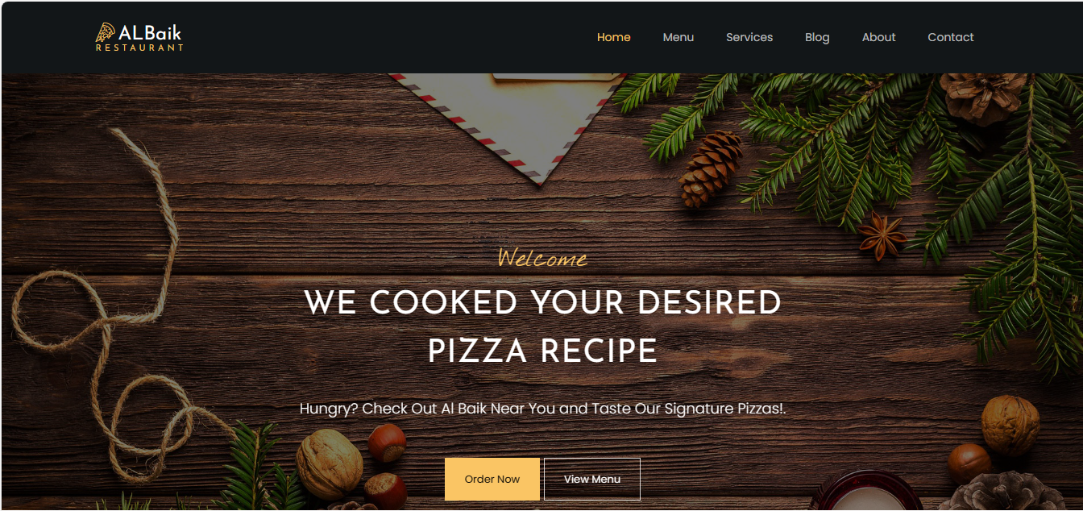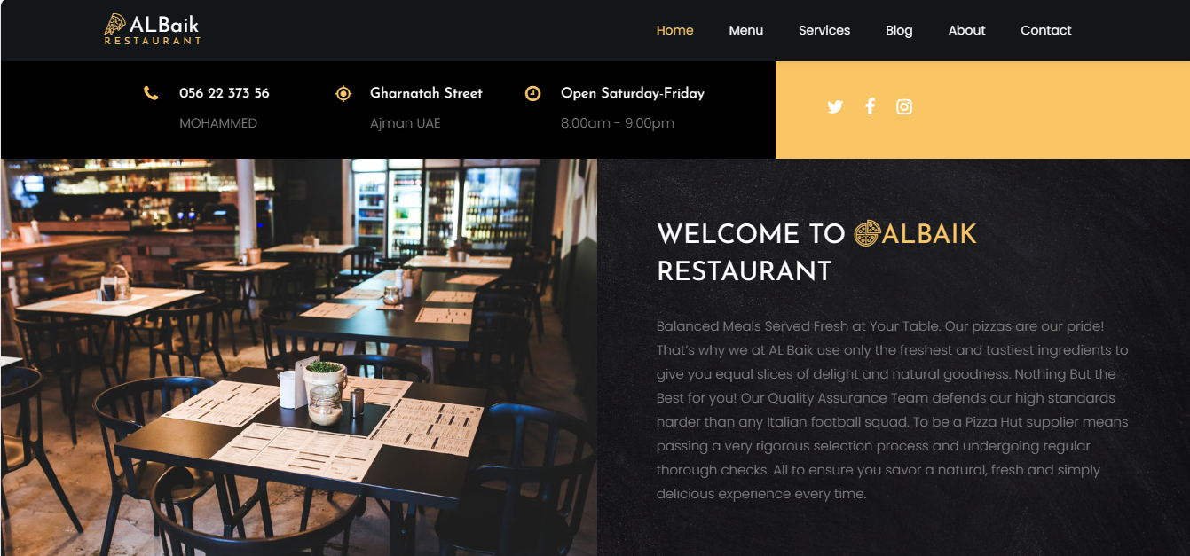

**OUR MENU**

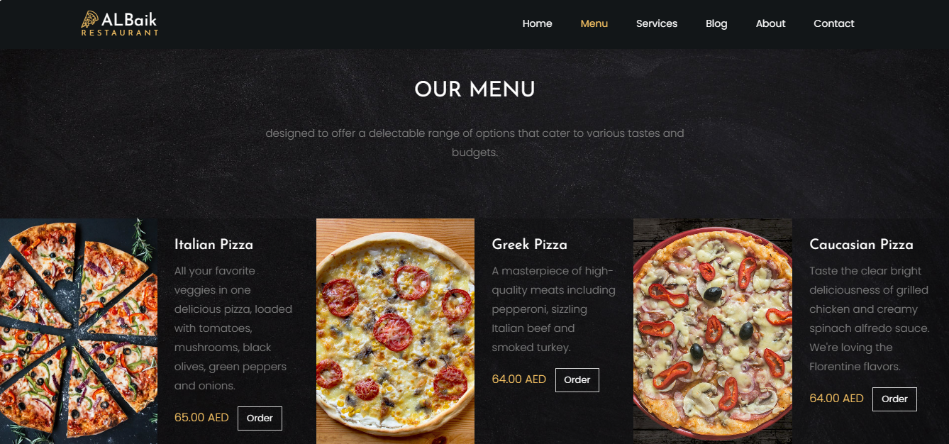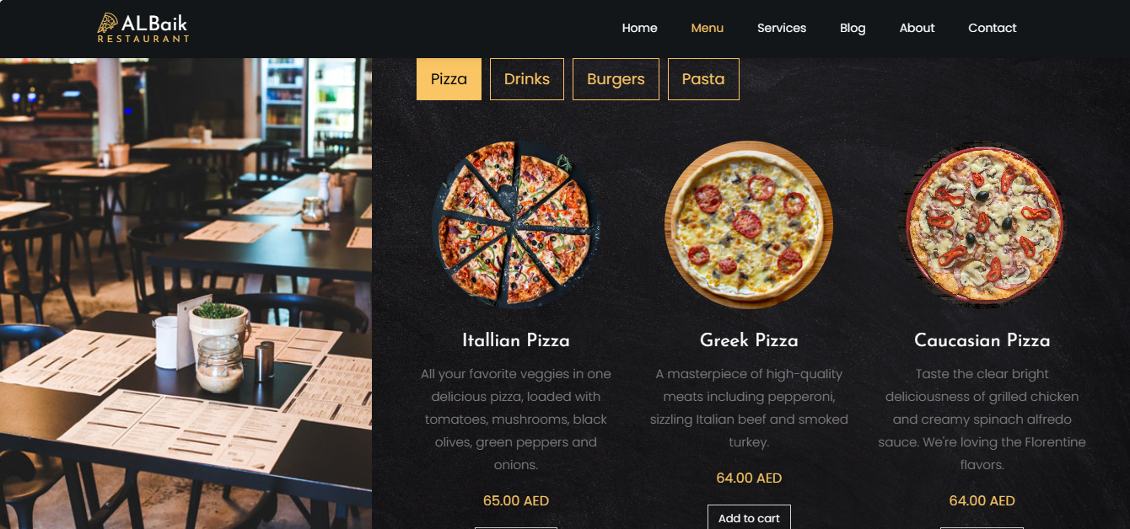

**BOOK TABLE**

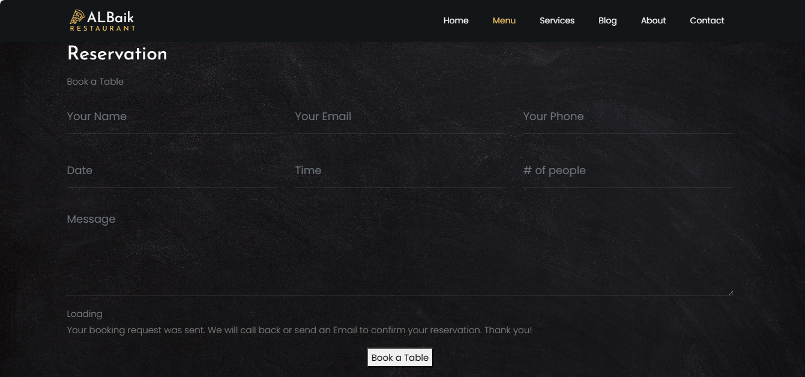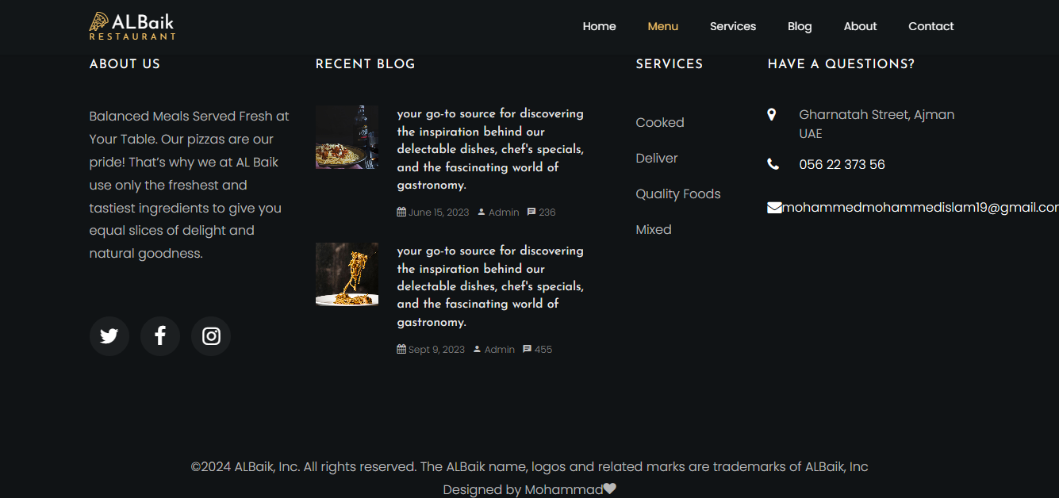

**OUR SERVICES**

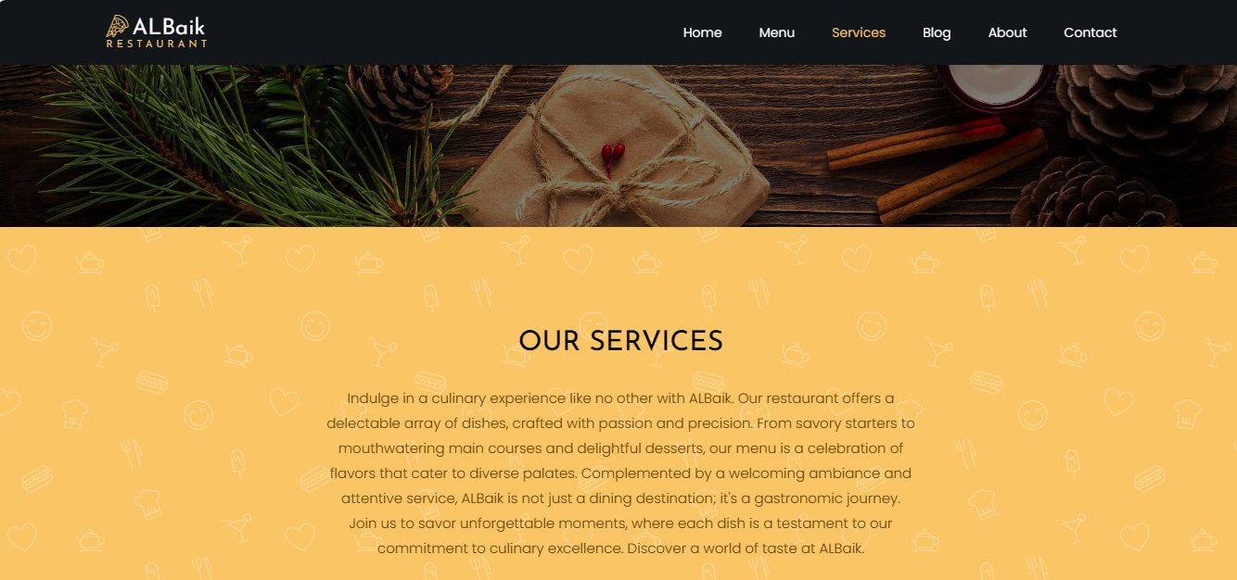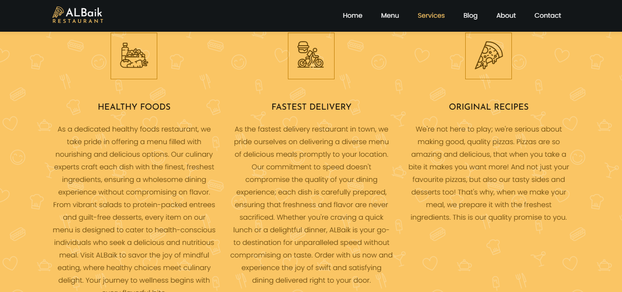

**OUR BLOG**

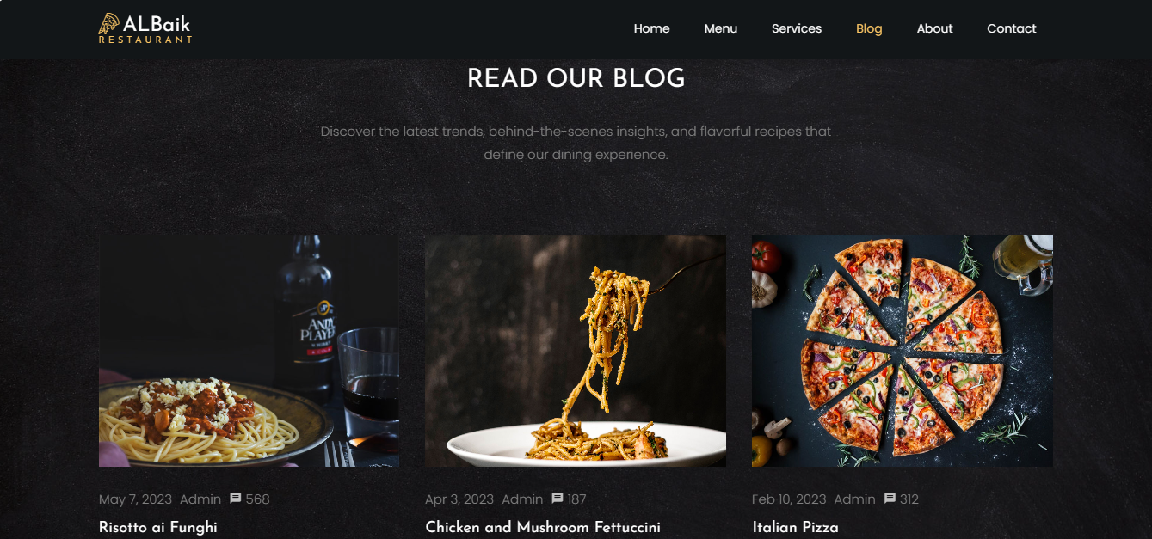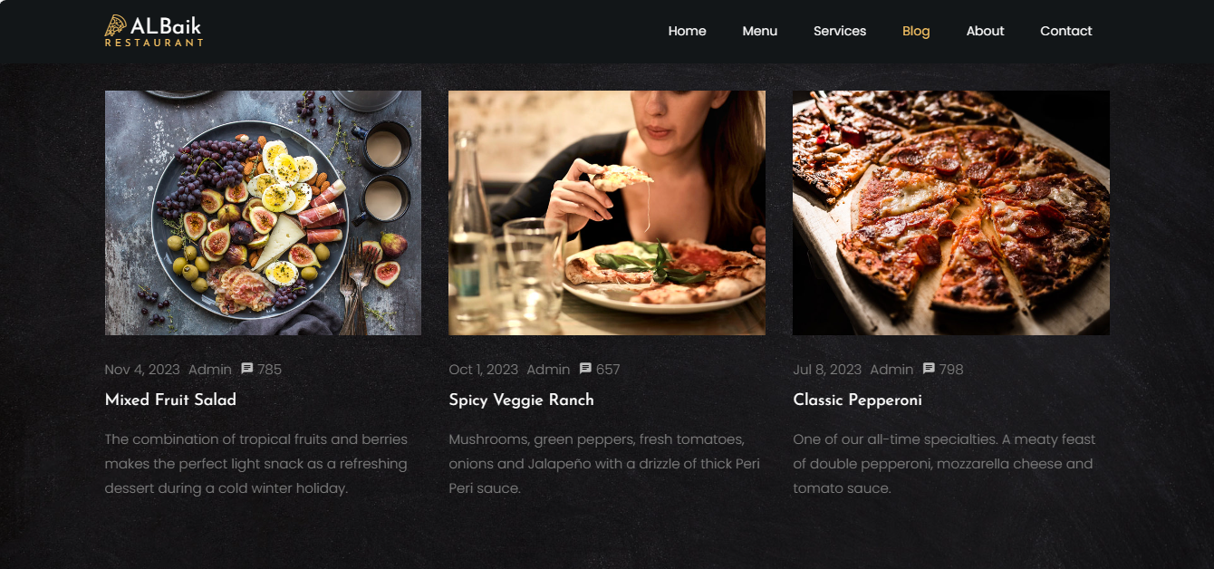

**ABOUT**

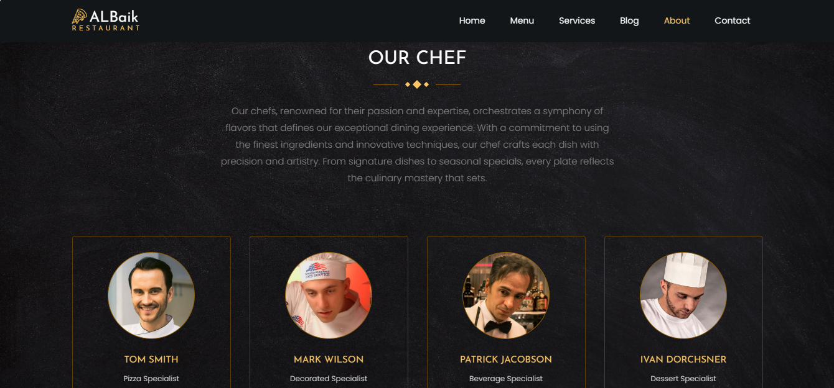

**CONTACT US**

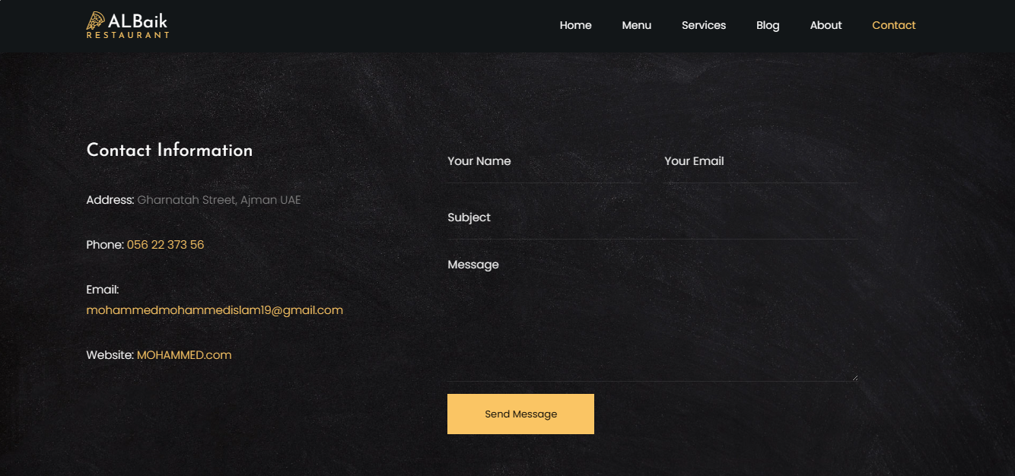

**Project Overview:**

The objective of this web development project was to create a robust and visually appealing website for a restaurant, addressing the specific requirements outlined by the owner. The central focus was on ensuring a seamless user experience, emphasizing the separate categorization of food and drink sections as per the owner's request.

**Owner's Requirements:**

The owner provided a detailed set of requirements to be incorporated into the website. Notably, the key directive was to distinctly present the various food and drink offerings. This necessitated the creation of separate sections for each category, enhancing user navigation and overall usability.

**Implemented Changes:**

In response to the owner's directives, the following key changes were implemented:

**1. Separate Sections for Food and Drinks:**

Distinct sections were created on the website to showcase the diverse offerings of food and drinks. This ensures clarity for visitors, allowing them to easily navigate and explore the menu items of their choice.

**2. Visual Representation:**

To enhance the user experience, each menu item is accompanied by visually appealing images. This addition aligns with the owner's vision of not just providing a list of items but creating an immersive and enticing presentation.

**3. Intuitive Navigation:**

User-friendly navigation was a paramount consideration. The website layout was designed to facilitate effortless movement between the different sections, enabling visitors to explore the menu comprehensively.

**4. Responsive Design:**

Recognizing the importance of accessibility across various devices, the website was optimized for responsiveness. Whether accessed on desktops, tablets, or smartphones, the design ensures a consistent and enjoyable experience.

**Technical Considerations:**

While implementing these changes, various technical aspects were taken into account:

**1. Database Structure:**

The backend database was structured to efficiently manage and retrieve data related to food and drink items. This organization ensures seamless updates and additions in the future.

**2. Content Management System (CMS):**

The implementation of a robust CMS allows for easy management of menu content. This empowers the restaurant staff to update offerings, prices, and images without requiring technical expertise.

**3. Mobile Optimization:**

Given the prevalence of mobile users, special attention was given to optimizing the website for mobile devices. This involved thorough testing to guarantee a smooth experience on smaller screens.

The implemented changes align with the owner's explicit requirements, particularly the separation of food and drink sections, enhancing the overall functionality and aesthetics of the restaurant website. The collaboration between design and development teams was instrumental in translating the owner's vision into a user-friendly and visually engaging digital platform.

**Project Overview:**

The objective of this project was to design and develop a multipage website, adhering to the specifications outlined in the design document. The use of HTML and CSS served as the primary programming languages for this endeavor, providing a foundation for building a visually appealing and functional website.

**Design and Development Evaluation:**

**1. Adherence to Design Document:**

The design and development process was closely aligned with the specifications detailed in the design document. The multipage structure was implemented, featuring distinct sections for various content categories. This ensured a cohesive user experience in line with the initial project vision.

**2. Technical Challenges Faced:**

a. Dynamic Pricing Algorithm:

Implementing a dynamic pricing algorithm based on user behavior presented a complex challenge. The JavaScript logic required careful testing to ensure accurate calculations. Debugging and refining the algorithm took significant time but resulted in a personalized pricing feature.

b. Payment Gateway Integration:

The integration of a secure payment gateway posed challenges due to stringent security protocols. Ensuring compliance with payment industry standards and seamless user experiences required collaboration with the payment service provider. Persistent testing and communication were vital for successful integration.

**3. Visual Design Iterations:**

The visual design underwent iterations, particularly in the product display and checkout pages. Feedback from stakeholders prompted adjustments in color schemes and layout. The iterative design process facilitated improved aesthetics and alignment with the brand's identity.

**4. Cross-Browser Compatibility:**

Ensuring the website's compatibility across various browsers proved challenging. Divergent rendering behaviors and performance disparities necessitated meticulous testing and adjustments in the CSS stylesheets to achieve consistent visual presentation.

**5. User Feedback Integration:**

Continuous user feedback was integrated into the development process. Regular usability testing sessions and feedback surveys guided adjustments in the user interface and overall user experience. Iterative improvements were made based on real-time user insights.

**Conclusion:**

The e-commerce website design and development successfully translated the design document into a functional platform. Overcoming technical challenges such as dynamic pricing and payment gateway integration showcased the team's problem-solving capabilities. The iterative design process and user feedback integration contributed to a final product that met stakeholder expectations.

**Test Plan for Restaurant Website**

**Introduction:**

The purpose of this test plan is to ensure the effective and reliable functionality of the restaurant website. The website aims to provide users with a seamless experience in accessing information, viewing the menu, and making reservations. The testing process will cover various aspects, including functionality, usability, security, and performance.

**Objectives:**

Verify that all features and functionalities outlined in the design document are implemented correctly.

Ensure the website is user-friendly, providing an intuitive navigation experience.

Validate the security measures implemented to protect user data and prevent vulnerabilities.

Evaluate the performance of the website under various conditions, including different devices and network speeds.

**Test Scope:**

**In-Scope:**

**Functionality Testing:**

Navigation through different sections (Home, Menu, About Us, Contact).

Menu item display and details.

Reservation form submission.

Contact form submission.

Mobile responsiveness.

**Usability Testing:**

Intuitive layout and navigation.

Consistent design and branding.

Clear and concise menu presentation.

User-friendly reservation and contact forms.

**Security Testing:**

SSL certificate verification.

Form input validation to prevent SQL injection and cross-site scripting.

Secure storage of user data.

**Performance Testing:**

Load time for different pages.

Performance on various devices (desktop, tablet, mobile).

Responsiveness under different network speeds.

**Out-of-Scope:**

Payment processing (if not applicable for reservations).

Integration with external systems (e.g., third-party APIs) not directly related to the core website functionalities.

**Test Environment:**

**The testing will be conducted in the following environments:**

**Development Environment:**

Local servers and databases used during development.

**Staging Environment:**

A replica of the production environment for final testing before deployment.

**Production Environment:**

The live website accessible to end-users.

**Test Cases:**

**Functionality Testing:**

Verify that all menu items are correctly displayed with accurate details.

Test the reservation form by submitting valid and invalid data.

Test the contact form by submitting inquiries with valid and invalid data.

Verify that the navigation menu works correctly on all pages.

Test the mobile responsiveness on various devices.

**Usability Testing:**

Evaluate the intuitiveness of the website's layout and design.

Check for consistency in branding elements (colors, logo placement).

Verify that menu items are presented in a clear and organized manner.

Test the user-friendliness of the reservation and contact forms.

**Security Testing:**

Verify the presence of an SSL certificate and secure HTTPS connection.

Attempt to submit malicious data in forms to test input validation.

Review code for potential security vulnerabilities.

Check for secure storage and handling of user data.

**Performance Testing:**

Test the load time of different pages, especially the home and menu pages.

Test the website's performance on various devices and browsers.

Test the website's responsiveness under different network speeds.

**Test Responsibilities:**

**Developers:**

Conduct unit testing during development.

Address and fix bugs identified during testing.

**Testers:**

Conduct integration testing, system testing, and UAT.

Document and report issues found during testing.

**Project Manager:**

Oversee the testing process.

Approve the release for production.

**Exit Criteria:**

All high-priority issues identified during testing are resolved.

The website functions as intended, meeting the design document requirements.

Testers and stakeholders provide approval based on UAT results.

All security vulnerabilities are addressed and verified.

**Conclusion:**

This test plan aims to ensure the restaurant website's reliability, security, and performance. Rigorous testing at different stages will contribute to the successful deployment of a high-quality and user-friendly website.

**Assessing the Quality Assurance (QA) Process in Project Development**

**Introduction:**

Quality Assurance (QA) plays a pivotal role in ensuring the successful development and deployment of projects. It encompasses processes and methodologies aimed at delivering a product that meets or exceeds customer expectations. This assessment aims to evaluate the effectiveness of the QA process in our project development lifecycle, identifying strengths, areas for improvement, and recommendations for enhancing overall quality.[10]

**Objectives:**

**Evaluate QA Processes:**

Assess the comprehensiveness and effectiveness of current QA processes in place.

Ensure alignment with industry best practices and standards. [10]

**Review QA Documentation:**

Examine the documentation related to QA processes, including test plans, test cases, and defect reports.

Evaluate the clarity and completeness of documentation. [10]

**Assess Test Coverage:**

Analyze the extent of test coverage across different phases of the development life cycle.

Identify any gaps in testing coverage. [10]

**Examine Defect Management:**

Review how defects are identified, documented, and managed throughout the development process.

Evaluate the efficiency of defect resolution. [10]

**Evaluate Automation Practices:**

Assess the extent of test automation implementation.

Identify areas where test automation can be beneficial. [10]

**Analyze Collaboration:**

Evaluate the collaboration between development, QA, and other project stakeholders.

Identify communication channels and feedback mechanisms. [10]

**Assessment Methodology:**

The assessment will be conducted through a combination of document reviews, interviews with project team members, and analysis of historical project data. The evaluation will focus on the key areas outlined in the objectives, with an emphasis on continuous improvement. [10]

**Evaluation Criteria:**

**1. Effectiveness of QA Processes:**

Adherence to defined QA processes.

Identification and mitigation of risks.

Timely execution of QA activities. [10]

**2. Quality of QA Documentation:**

Clarity and completeness of test plans.

Precision in defining test cases.

Accuracy and relevance of defect reports. [10]

**3. Test Coverage:**

Extent of test coverage in unit, integration, system, and acceptance testing.

Inclusion of edge cases and boundary scenarios. [10]

**4. Defect Management:**

Efficiency in identifying and reporting defects.

Effectiveness of the defect resolution process. [10]

**5. Automation Practices:**

Percentage of test cases automated.

Effectiveness of automated tests in reducing manual testing efforts. [10]

**6. Collaboration:**

Effectiveness of communication channels.

Integration of QA processes with development workflows. [10]

**Recommendations and Improvement Plan:**

Following the assessment, a detailed set of recommendations and an improvement plan will be provided. These will include actionable steps to address identified weaknesses, enhance existing processes, and leverage opportunities for optimization. [10]

**Reporting and Presentation:**

A comprehensive report summarizing the assessment findings, recommendations, and improvement plan will be presented to project stakeholders. This presentation will serve as a platform for discussion, feedback, and alignment on the proposed changes to the QA process. [10]

**Conclusion:**

The assessment of the QA process in project development is a critical step in ensuring the delivery of high-quality software. Through a systematic evaluation, we aim to enhance our QA practices, address any shortcomings, and foster a culture of continuous improvement within our project development life cycle. [10]

[1] “What is the World Wide Web (WWW)? | Definition from TechTarget.” Accessed: Jan. 15, 2024. [Online]. Available: https://www.techtarget.com/whatis/definition/World-Wide-Web

[2] H. Diego, “Enumerate DNS,” Medium. Accessed: Jan. 15, 2024. [Online]. Available: https://higordiego.medium.com/enumerate-dns-194d5064a849

[3] “Understanding The Anatomy of a Website - WowMakers.” Accessed: Jan. 15, 2024. [Online]. Available: https://www.wowmakers.com/blog/anatomy-of-a-website/

[4] R. Shikha, “Unraveling the Intricacies: Interaction Design vs. Visual Design,” Medium. Accessed: Jan. 15, 2024. [Online]. Available: https://medium.com/@shikha.ritu17/unraveling-the-intricacies-interaction-design-vs-visual-design-56b1fabb6756

[5] “The Ultimate Guide to SEO Mastery: Strategies, Tips, and Success.” Accessed: Jan. 15, 2024. [Online]. Available: https://www.linkedin.com/pulse/ultimate-guide-seo-mastery-strategies-tips-success-amitabh-singh

[6] M. Wu, D. C. Kozanoglu, C. Min, and Y. Zhang, “Unraveling the capabilities that enable digital transformation: A data-driven methodology and the case of artificial intelligence,” *Advanced Engineering Informatics*, vol. 50, p. 101368, Oct. 2021, doi: 10.1016/j.aei.2021.101368.

[7] “Exploring the SEO Niche: An In-Depth Analysis,” AIContentfy. Accessed: Jan. 15, 2024. [Online]. Available: https://aicontentfy.com/en/blog/exploring-seo-niche-in-depth-analysis

[8] “Front End vs Back End Development: Unraveling the Key Differences.” Accessed: Jan. 15, 2024. [Online]. Available: https://www.linkedin.com/pulse/front-end-vs-back-development-unraveling-key-differences-vishnu-r

[9] anoriega, “How to Create a Website From Scratch (Step-By-Step Beginner’s Guide),” Berkeley Boot Camps. Accessed: Jan. 15, 2024. [Online]. Available: https://bootcamp.berkeley.edu/blog/how-to-create-website-from-scratch-guide/

[10] M. Waida, “What is Quality Assurance (QA) in Project Management? | Wrike,” Blog Wrike. Accessed: Jan. 15, 2024. [Online]. Available: https://www.wrike.com/blog/what-is-quality-assurance-project-management/